Worksheet: Finish a comic!
Grammar: Present continuous or present simple

Instruction
In this worksheet you can find a comic, but is isn’t finished.
Could you help the artist finishing this comic?
You only have to write the right sentences underneath the pictures.
The first picture is about a habit or something that you always, usually, never, often of sometimes do.
The second picture is about something you are doing now or at the moment which is different from your previous habit
You have to use the verb that has been given and form your own sentences!
Example:
Given word: To Work
 | 
On Monday I always work at home | But now I am working at the office

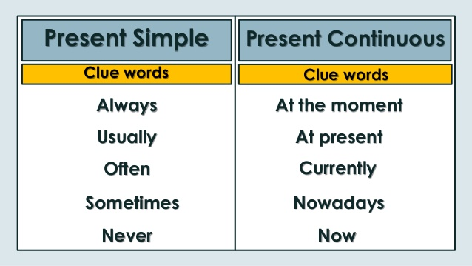

Worksheet: Finish the comic about changing habits
Exercise one: Given word: To sleep
 | 
Exercise two Given word: To play
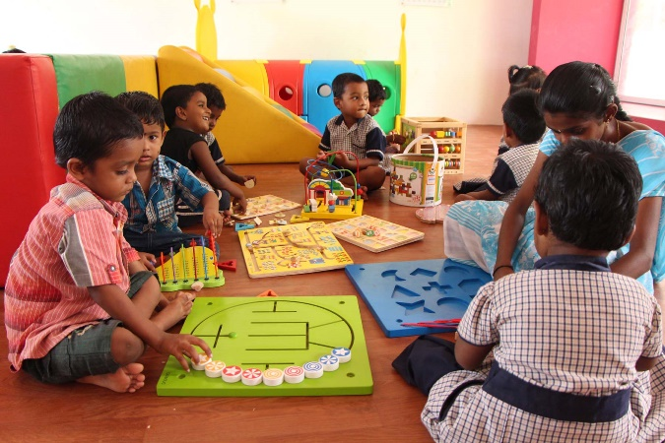 | 
Exercise three Given word: To listen
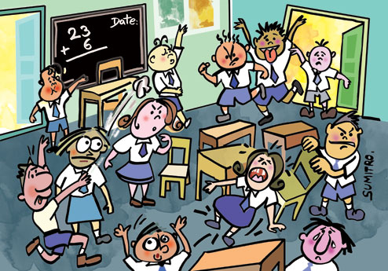 | 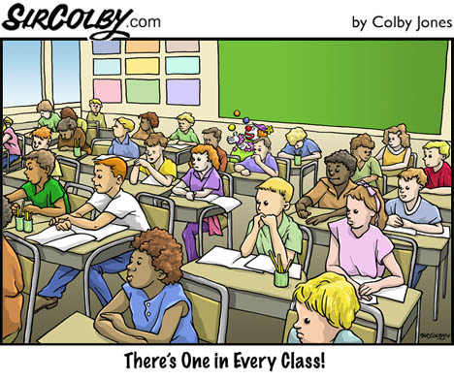

Exercise four Given word: To fly
 | 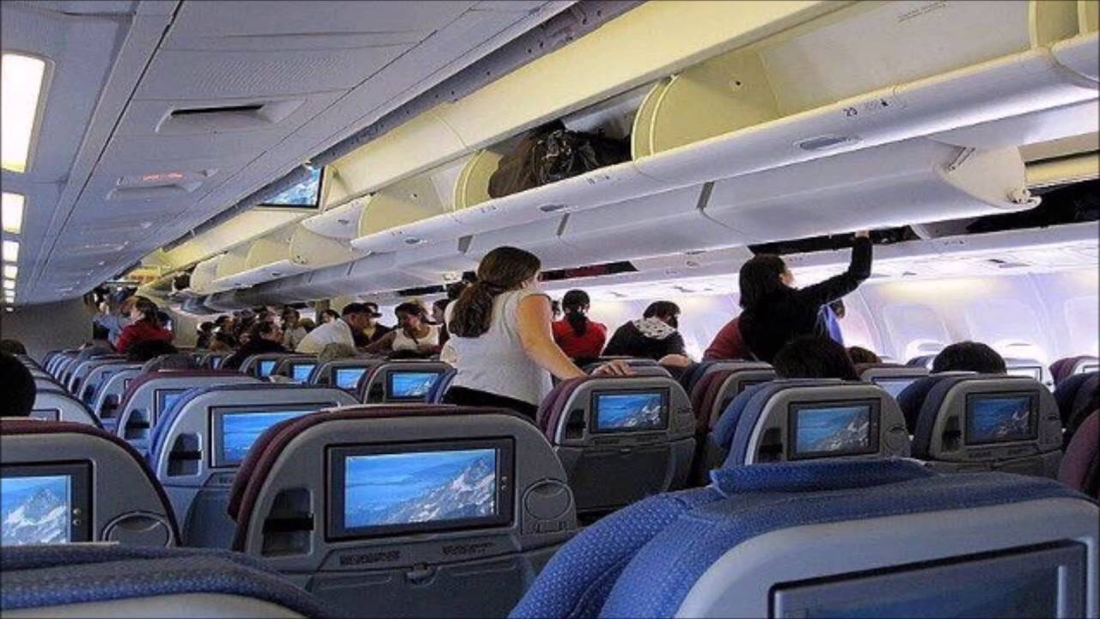
Exercise five Given word: To drink
 | 
Exercise six Given word: To eat
 | 

